

# Engineering Scalable and Reliable Software

PROJECT DESIGN AND REPORT

*Presented by*

**Group – 9**

**Members:**

Rohan Kadam, Aman Thapa Magar, Tom Naccarato, Jawad Nasar Shah, Mya Lwin, Rob Ryan, Moldir Zhumakazi

# Abstract

This report presents the study, design and analysis of a software project targeted at creating a Book Lending application. This project is developed as a part of the course module – ESRS as a tool to learn software development to enable deploying software systems which are scalable and dependable. The project has been created by the collaborative and determined efforts of the team members of Group-9.

# Acknowledgement

The team members of Group – 9 express sincere gratitude to our teacher and module convenor Prof. Hsi-Ming Ho for his constant support and invaluable insights throughout the course of this project. His expertise and guidance have been crucial in achieving success through the journey of the project development.

Furthermore, a heartfelt thank you to all the members of Project Group 9. The dedicated hard work, sheer determination, and collective effort of all the team members have played an important role in achieving the goals of developing this project. The commitment to excellence and working together has made this journey fulfilling and has provided a rewarding experience to all. Thank you all for your valuable contributions.

Contents

Abstract 1

Acknowledgement 2

INTRODUCTION 4

Overview 4

Project Tasks 5

N-Queens Problem 5

Polysphere Problem - 2 Dimension 5

Polysphere Problem - 3 Dimension 5

DEVELOPMENT 6

Development Methodology 6

Software Tools 6

Design Plan 6

Implementation 6

TESTING 7

N-Queens Problem 7

Polysphere Puzzle-2D 12

Polysphere Problem – 3-Dimention 18

CONCLUSION 20

Limitations 20

Future Improvements 21

# INTRODUCTION

## Overview

This comprehensive report unfolds an in-depth study and analysis, delving into a purposeful software initiative aimed at the development of book lending application. The primary objective of this application is to create a multi-user style application which enables like minded persons to connect with each other and share their common love for books. This application allows them to request & share books with each other building towards a sense of community for book lovers. The application is robust enough to handle server failures and scalable whenever required.

The development approach for this application involved the adoption of the agile methodology where the project was being continuously made deployable with small incremental features and the developers kept adding various functionality. One real-life scenario of changing requirement was simulated as well when the team decided the UI-UX needs to be changed and be made much more sophisticated. This strategic choice allowed team to proactively respond to the evolving needs and made them feel the importance of strictly following software development techniques learned in the past module. Only because of such techniques, it was possible to accommodate changes in the project even in the later stages.

# DEVELOPMENT

## Development Methodology

This section includes the methods used to develop the project.

## Software Tools

This section includes the software tools used to develop the project

## Design Plan

This section includes the flow charts and diagrams used to plan the project

## Implementation

This section includes the problem wise coding strategies and algorithms used to develop the project

# TESTING

Following sections lists the test cases and results for each game to evaluate the software functionality is as expected and meets the specified functional requirements. The goal of this phase is to ensure the functionality and reliability of the implemented code and algorithm fulfilling its intended purpose.

## N-Queens Problem

|  |  |  |  |
| --- | --- | --- | --- |
| S.No. | Test Case | Expected Result | Results |
| 1 | To test the successful launch of N-Queens Server | Successful Launch of Server | Server launched successfully.[Fig-1] |
| 2 | To evaluate the display of chess board is in accordance with the size selected. | The Chessboard is displayed when range is between 4-10 size. In case of ‘out of range’ input by the user, the server displays a pop up indicating incorrect range input. Display of chessboard should be.  accurate. | The results are as expected. [Fig-1][Fig-2] |

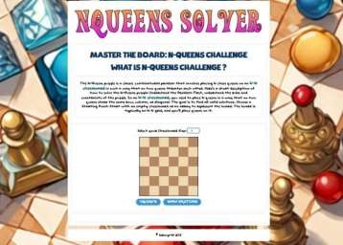

***Figure 1***

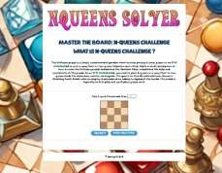

***Figure 2***

|  |  |  |  |
| --- | --- | --- | --- |
| S.No. | Test Case | Expected Result | Results |
| 3 | To test the validation of solution presented to user | **Case 1**: Display pop up to the user if the validation of their solution is correct. | Results are presented in [Fig-3] |
|  |  | **Case 2**: Display pop up to the user if the validation of their solution is incorrect. | Results are presented in [Fig-4] |

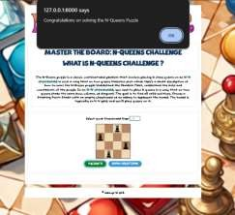

*Figure 3*

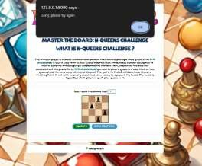

***Figure 4***

|  |  |  |  |
| --- | --- | --- | --- |
| S.No. | Test Case | Expected Result | Results |
| 4 | To test placement and removal of Queen Pieces by clicking. | First click on chessboard should place the Queen piece on that position and Second Click on the Queen piece should remove the  said piece. | Each expected action is performed successfully.  [Fig-5][Fig-6] |

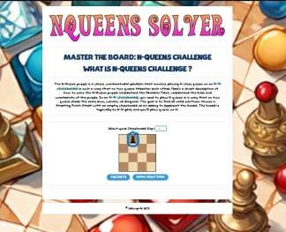

***Figure 5***

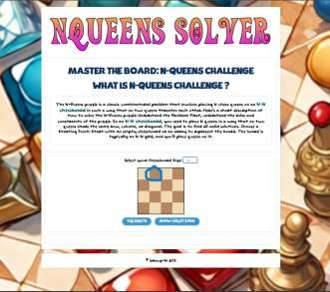

***Figure 6***

|  |  |  |  |
| --- | --- | --- | --- |
| S.No. | Test Case | Expected Result | Results |
| 5 | To test the number of Queen pieces placed is not more than the corresponding size of the  Chessboard. | To ensure if user attempts placing Queens more than the size of the Chessboard, an error pop up is  displayed to the user. | The user is displayed the error pop up message as  expected.[Fig-7] |

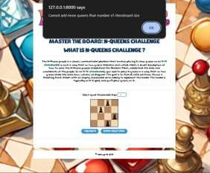

***Figure 7***

|  |  |  |  |
| --- | --- | --- | --- |
| S.No. | Test Case | Expected Result | Results |
| 6 | To verify the accuracy of the presented solutions | Accurate solutions are displayed after clicking “Show Solution” button according to the partially filled or empty chessboard and solutions are hidden after clicking  “Hide Solution” button. | The presented solutions are accurate as per the rules of the  game.[Fig-8][Fig-9] |

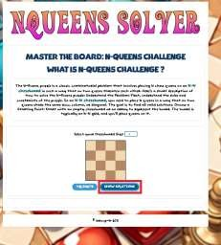

***Figure 8***

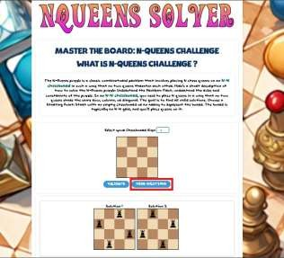

***Figure 9***

## Polysphere Puzzle-2D

|  |  |  |  |
| --- | --- | --- | --- |
| S.No. | Test Case | Expected Result | Results |
| 1 | To test the successful launch of Polyshpere Puzzle -2D Server | Successful Launch of Server | Server launched successfully.[Fig-10] |

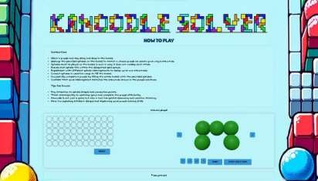

*Figure 10*

|  |  |  |  |
| --- | --- | --- | --- |
| S.No. | Test Case | Expected Result | Results |
| 2 | To test the placement of polysphere pieces into the  board. | Accurate placement of the pieces by dragging and dropping polysphere pieces onto the board as per user’s expectation and removal of the last placed piece by clicking  “undo” button. | Dragging and dropping action is as expected  [Fig-11][Fig-12]  as well as “undo” action.  [Fig-13][Fig-14] |

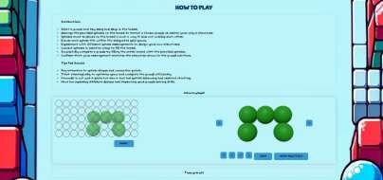

*Figure 11*

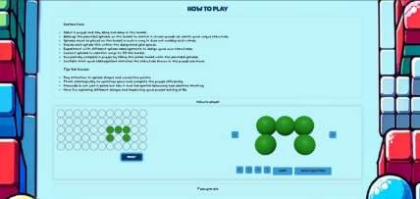

*Figure 12*

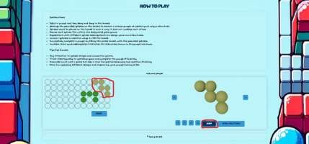

*Figure 13*

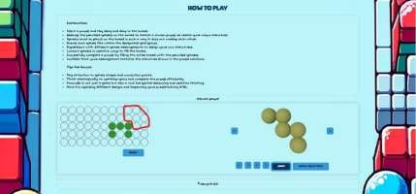

*Figure 14*

|  |  |  |  |
| --- | --- | --- | --- |
| S.No. | Test Case | Expected Result | Results |
| 3 | To test the accuracy of rotation and restructuring of the polysphere pieces  using the provided buttons. | **Case 1**: Verification of left and right rotate symbol buttons.  90 degrees left or right Rotation of the polysphere pieces by click of each respective left or right rotate  symbol button. | Button functions are as expected. [Fig-15][Fig-16]  [Fig-17] |
|  |  | **Case 2**: Verification up-down and side-to-side flip symbol buttons.  180 degrees’ flip of the polysphere pieces by click of up-down or side-  to-side flip symbol buttons. | Button functions are as expected. [Fig-18][Fig-19]  [Fig-20] |

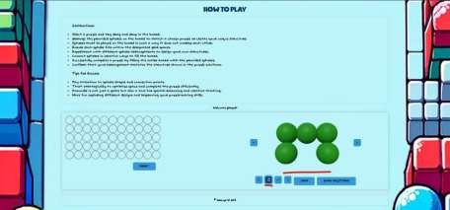

*Figure 15*

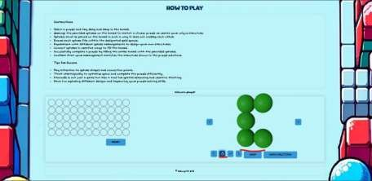

*Figure 16*

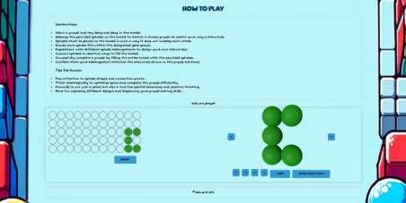

*Figure 17*

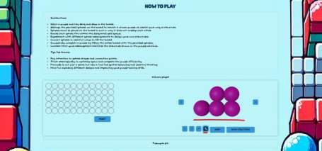

*Figure 18*

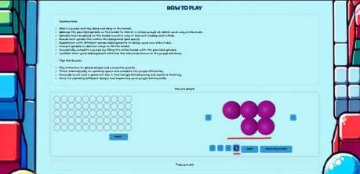

*Figure 19*

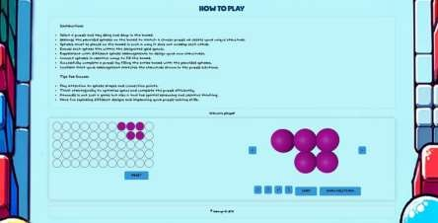

*Figure 20*

|  |  |  |  |
| --- | --- | --- | --- |
| S.No. | Test Case | Expected Result | Results |
| 4 | To test the accuracy of the presented solutions. | **Case 1**: To verify functionality of “Show Solution” Button  Solutions are displayed after  clicking “Show Solution” button and in case of no possible solutions for user’s piece arrangement on board, a message is displayed | Button function is as expected. [Fig- 21] |
|  |  | **Case 2**: To verify the accurate solution is presented. | Accurate solution is presented.[Fig-22] |

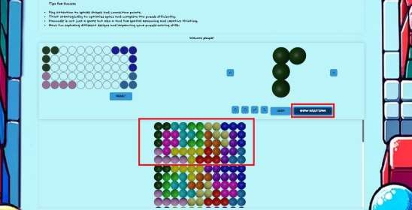

*Figure 21*

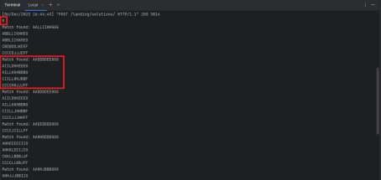

*Figure 22*

|  |  |  |  |
| --- | --- | --- | --- |
| S.No. | Test Case | Expected Result | Results |
| 5 | To test the Reset button | The “Reset” button should clear all the pieces from the board. | Button function is as expected. [Fig-  23][Fig-24] |

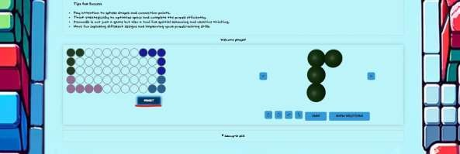

*Figure 23*

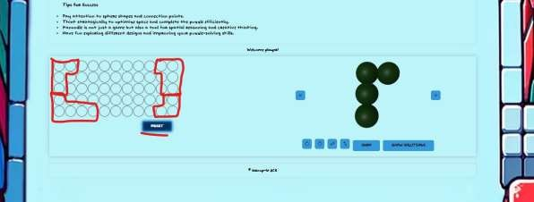

*Figure 24*

## Polysphere Problem – 3-Dimention

|  |  |  |  |
| --- | --- | --- | --- |
| S.No. | Test Case | Expected Result | Results |
| 1 | To test the successful launch of Polyshpere Puzzle -3D Server | Successful Launch of Server | Server launched successfully.[Fig] |

|  |  |  |  |
| --- | --- | --- | --- |
| S.No. | Test Case | Expected Result | Results |
| 2 | to test the 3D rotation of the polyshpere pyramid. | Dragging of the mouse should  display the view of the pyramid from 3-dimensional perspective. |  |

|  |  |  |  |
| --- | --- | --- | --- |
| S.No. | Test Case | Expected Result | Results |
| 3 | To verify selection of the shapes | Display of the choices of the shapes by selecting right or left swipe buttons. |  |

|  |  |  |  |
| --- | --- | --- | --- |
| S.No. | Test Case | Expected Result | Results |
| 4 | To test the colouring of the spheres in the pyramid according to shape selected by the user. | **Case 1**: Clicking on the spheres should colour it in the shade of the shape selected by the user |  |
|  |  | **Case 2**: Colouring of the spheres should be restricted to the shape selected. The number of spheres in the pyramid that can be coloured should be equal to the number of spheres in the shape displayed as  selected by the user. |  |

|  |  |  |  |
| --- | --- | --- | --- |
| S.No. | Test Case | Expected Result | Results |
| 5 | To test the Solve, Clear and Stop functions. | **Case 1**: "Solve" button should give the number of solutions as well as visual representation of the solutions on the pyramid for partial and empty configuration. |  |
|  |  | **Case 2**: "Stop" button will stop the listing of solutions and Clear button should clear all the coloured spheres in the pyramid to reset the  game. |  |

|  |  |  |  |
| --- | --- | --- | --- |
| S.No. | Test Case | Expected Result | Results |
| 6 | To test the visual aspects of the pyramid. | The slider button should display the visual representation of the pyramid according to the number of  layers selected in 2-D as well as 3-d. |  |

# CONCLUSION

In conclusion, this comprehensive report outlines a purposeful software initiative focused on the development of a web-based game application, emphasizing interactive puzzle resolution. The project's central objective is to empower users to independently engage with and solve intricate puzzles, including the N-Queens puzzle and the Polysphere Puzzles in both 2D and 3D dimensions.

The web application is designed to facilitate active user participation in the puzzle-solving process, allowing navigation through chessboard scenarios, strategic queen placements, and the placement of various shapes on grids for Polysphere Puzzles.

The is project is implemented through agile methodology to provide requested features and feedback from the client. Utilized GitHub as the central platform for tracking all development activities in collaboration with the customer.

The project also underwent thorough testing to verify reliability and functionality of the web-based game application.

## Limitations

**N-Queens Puzzle**

* The Chessboard size is limited to 10 Queen pieces due to computation complexities emerging with higher size boards as heavy resources are consumed when computing the solutions.

**Polyspere Puzzle – 2D**

* The user cannot perform combinations of rotation and flips due to logical constraints.

**Polyshere Puzzle – 3D**

* Placement of the shapes can only be done unidirectional relative to the initial placement of the first sphere.
* Users cannot place the pieces diagonally as the shape of pieces cannot be skewed from its original shape.
* The user cannot drag and drop the pieces on the pyramid. The game relies on the User’s understanding of the 3-d structures and visual knowledge of the shapes. The limitation is caused due to heavy

reliance on libraries such as Three.js and Orbit Controls that are used to generate the 3-D elements of the Game.

## Future Improvements

To improve the puzzle-solving capabilities, the optimization of time complexity and the enhancement of algorithmic efficiency in the computation of solutions for each puzzle will be required in the project. The primary goal is to guarantee the time required for solving puzzles is minimized, and the implemented algorithms show efficiency in delivering accurate solutions. By improving the time complexity, the overall performance of the puzzle-solving mechanisms will be enhanced, providing users with a smoother experience in navigating through complex problems.

Furthermore, enhancement in both the user experience and the visual features of the system can also be implemented. This improvement can elevate the overall usability and aesthetics of the application. Enhancing the user experience requires improving the interface, navigation flow, and overall interaction design for a more intuitive, efficient, and satisfying engagement for the users.